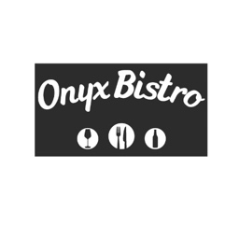

Spring Wine Pairing Dinner
Flying H Vineyards
Thursday April 11^{th.} 6-9pm
$95 per guest, *reservation required *

Course 1 : Pork & Asian Pear Spring Roll, house-made pickles
& citrus plum glaze
Paired w/ Flying H Sauvingon Blanc

Course 2: Grilled Prawns w/ coconut lemongrass burre blanc, Taiwanese style cabbage
Paired w/ Flying H Chardonnay

Course 3: Vietnamese Meatball Pho w/ 8 hour bone marrow broth, rice noodles, fresh herbs, spring onion, crispy garlic chips
Paired w/ Flying H Pinot Noir

